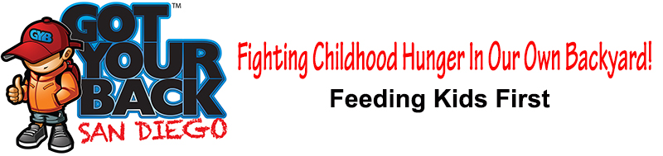
DONATION RECEIPT
On behalf of our staff and all of the children who benefit from the Got Your Back San Diego project, thank you for your generous support. Your gift will go a long way toward providing much needed nutritious meals to food insecure children in the San Diego Schools. Got Your Back San Diego is a food program of Feeding Kids First, formerly the American Relief Organization, a recognized 501c3 non-profit corporation. Your donation is tax-deductable. Our Federal Tax Identification Number is 20-8220093. Please make a copy of this receipt for your records and mail the original copy to Got Your Back along with your donation.

PLEASE INCLUDE THE FOLLOWING INFORMATION:
Donor’s Name: ____________________________________________________________

FOR CREDIT CARD AND CHECK DONATIONS:
Account Holder’s Name
(If Different Than Donor)
As It Appears On the Card:________________________________________________________
Billing Address: ____________________________________________________________
City, State, Zip: ____________________________________________________________
Donation Amount: ____________________________________________________________
Credit Card #: ____________________________________________________________
Expires: __________________ 3 or 4 Digit Code: _____________________
Check #: __________________

DONATED ITEM OTHER THAN MONEY
Description: ___________________________________________________________________
Condition: Operational Non-Operational
Estimated Value: $ ____________________

